MiCAN Technologies Established a Development Office in Europe at Biolabs Heidelberg for the Development of an Alternative Thermogenic Test Product (MylcMAT) Using Human Immortalized Monocyte Cells (aMylc)

MiCAN Technologies Inc. (hereinafter referred to as “MiCAN”), a member company of Kobe Biomedical Innovation Cluster (KBIC) is developing a MAT (Monocyte Activation Test) product (MylcMAT) using human immortalized monocyte cells (aMylc) with its proprietary blood cell production technology. In Europe, the rabbit thermogenicity test has been decided to discontinue by the end of 2025 due to its high burden on animals. Therefore, it is desired to develop and provide an alternative testing method that does not use animal resources.

Since 2018, MiCAN has been working on the development of an alternative to exothermic substance testing using aMylc. Last year, MiCAN presented at PharmaLab Congress, one of the largest safety testing conferences in Europe, and received a lot of positive feedback from European companies. On this occasion, MiCAN is pleased to announce the establishment of a development office in Europe at Biolabs Heidelberg in Germany in January 2024, and have started activities to bring products to the European market. The development office in Europe will be responsible for studying the European specifications of the product and introducing the technology, including actual product evaluation by potential customers in Europe.

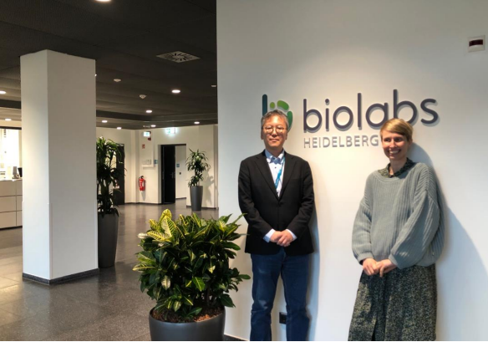
Dr. Ann-Kristin Mueller(Site Director) and Mr. Kazuo Miyazaki (CEO, MiCAN Technologies) @ Biolabs Heidelberg

<Biolabs Heidelberg>
BioLabs Heidelberg is an incubation facility designed for life science entrepreneurs, offering well-equipped laboratory and office space combined with access to partners such as pharmaceutical companies.

https://www.biolabs.io/heidelberg

<About MiCAN Technologies Inc.>
A Kyoto University spinout company having production technologies to generate high performance artificial blood cells from stem cells. Their Mylc cell series are highly controlled immature dendritic cells suitable for evaluation of efficacy of drug discovery and safety assessment. Recently launched cMylc kit is exclusively designed for COVID-19 vaccines and drug development. The coronavirus optimized myeloid lineage cells works as host cells with giving stable and robust performances for your research on COVID-19.
<Contact>
MiCAN Technologies, Inc.
Kazuo Miyazaki, Chief Executive Officer
Mail: kmiyazaki”AT”micantechnologies.com
Please replace “AT” with @ when sending the E-Mail.
URL: https://www.micantechnologies.com/

